**Assignment 17.3**

Write a mapreduce job that takes configuration from command line (min.word.count). Based on the configuration, it should perform count of words from a document and produce only those words in the output whose count is greater than or equal to the configuration.

**DRIVER:**

In driver we should make the class extends configured class and implement tool interface and tool runner static method run which creates a configuration object before the run method

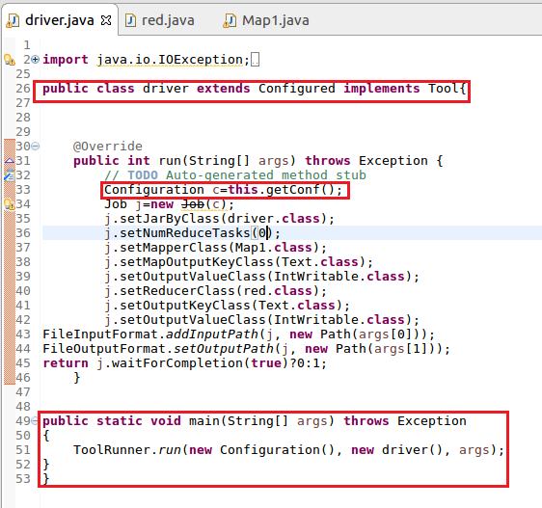

**MAPPER:**

In Mapper, I am using hash map and If hashmap contains the word the count will be incremented or else a count of 1 will be made and USED **context.getconfiguration** to get the value for key ”Name” .

**Step2:** words will be counted only if the occurrence of word is greater than or equal to the given value

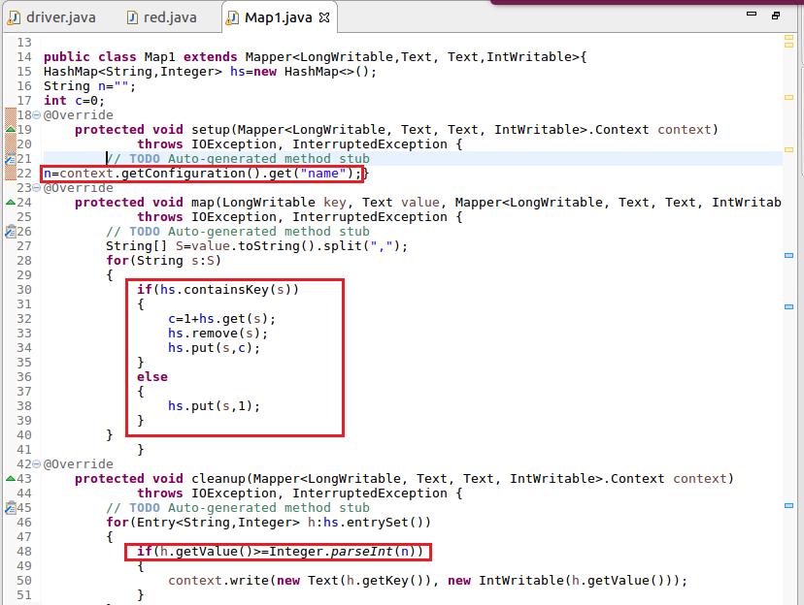

**RUNNING JAR:**

Here I have specified the mincount=3 by giving –D name=3 as highlighted below

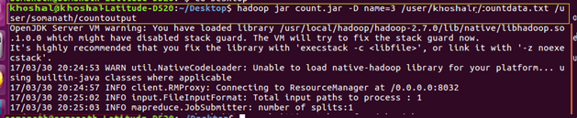

**INPUT file:**

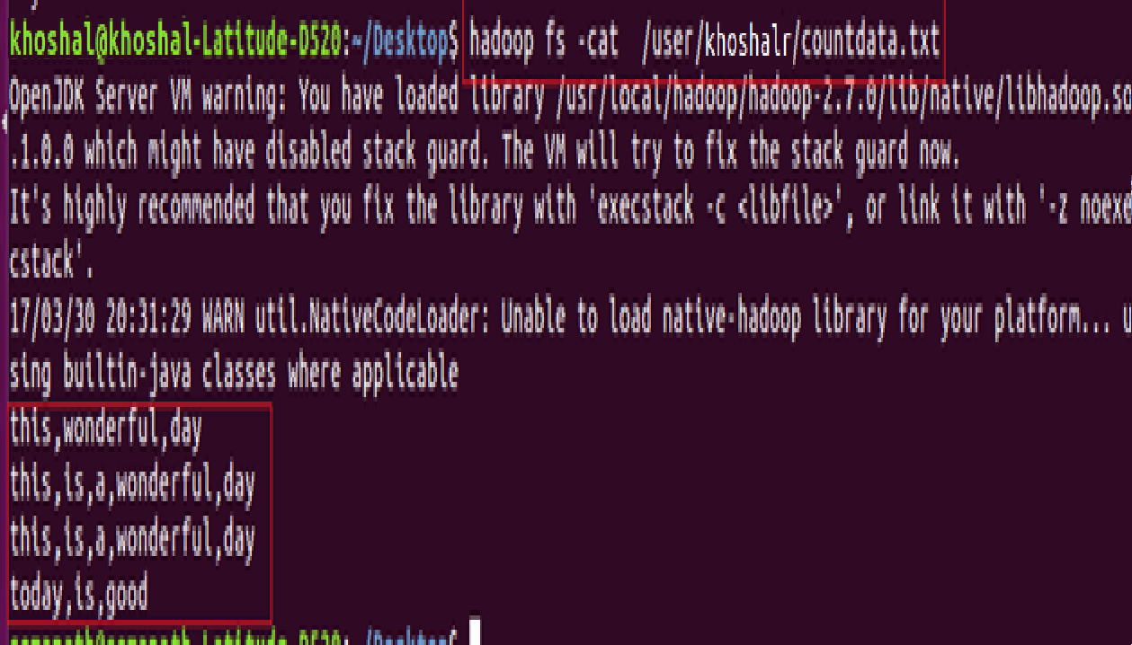

**OUTPUT:**

**INFERENCE:** ONLY WORDS WITH OCCURRENCE GREATER THAN OR EQUAL TO 3 IS COUNTED

